**ASSP Delmarva Chapter Board Meeting Agenda / Minutes**

**Attendees:**

Northam, Clauss, Griscavage, Jones, Cruice, Bedard, Helms, Dukes

**ASSP Delmarva Chapter Financial Report** – Ron Dukes

          Final acceptance of Venmo use -agreement reached for use. Motion passes to retain VENMO.

          Open forum discussion – charge for Web Ex attendance -Discussed charging for WebEx meetings. Determine if Zoom can be utilized to charge with Zoom.

                     Who will do follow-up?-Joe Bedard and Derek Helms

                     What is acceptable charge? $10 for Web Ex and $20 for an in person meeting and lunch meeting. Motion made and passed for charges listed above.

Discuss how contact hours can be used and how can they be registered for: Follow up by John Griscavage.

Savings:

517.41 spare from closing Northern Delmarva Section

6472.18 checking

3868 CD

Total = 10,857

**Group Feedback – Joint Session with SHRM HR Chapter**

**-Discussed plan to have continued Joint sessions with SHRM HC Chapter.**

**Positive comments were received from the last meeting.**

**Technical Meetings**

          Met required 4 tech meetings for this fiscal year for COMT credit

          June meeting -Round table for COVID-19 and preparation for the fall. Frank, Dawn, and Jerry. Motion made and passed.

          End of year activity - Zoom happy hour proposed by Frank! Lisa to help. July

                Occupation health nurses joint meeting. – Follow up with Wellness leadership.

                Emergency managers association. Chuck to follow up

                Environmental managers associations that could participate in joint meetings. Chuck to follow up

**ASSP Region 6 Spring ROC Update**

          Main topic of conversation beyond routine

Meeting attendance and

Regional resources for Web-Ex/ZOOM conference speakers

ROC Attendance was very favorable. Double attendance for ASSP chapter.

**ASSP Reports Due**

          Leadership Report in COMT Link – 5/15/2020 – Joe Bedard -Almost complete

          Annual Financial Report in COMT Link = 5/15/2020 – Ron Dukes -almost complete

**Officer Elections -Sept will require nominations**

          President – Joe Bedard – Two year – ends 6/2021

          Vice President – John Griscavage – ends 6/2021

          Treasurer – Ron Dukes – ends 6/2021

          Secretary/Membership Co-Chair – ends 6/2021

          Newsletter Chair/Membership Co-Chair – ends 6/2021

**Student Chapter Support – Fall ROC and Region 6 PDC – 9/16 thru 9/18**

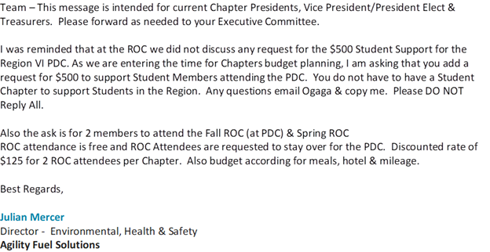

Verify payment made and student chapter and discussion on sending donation to support the fall ROC

**ASSP Leadership Conference** -  Chicago, IL – Oct 15 thru 17

          Possible attendee – John Griscavage – VP / President Elect

John will attend.

**ASSP Fall ROC and PDC** – Myrtle Beach, SC September 16 thru 18

Likely to occur. No notes for attendees currently.

New items:

COVID meeting in June – Panel – Griscavage, Cruice, Northam, Medical Professional